- Imperative commands (single line commands to create the objects)
  - kubectl run my-pod --image=nginx [ here run is used, not create ]
    - restartPolicy: always
always: restart pod even if the container exits with exit coode 0
onFailure: restart pod only if container’s exit code is non-zero
never: never restart the pod even if container stops.
    - namespace: default
namespace is logical grouping of a cluster to separate logically like dev, prod, teams ..etc.
    - labels: run: my-pod
    - port: not exposed
[ port is never exposed from container though, means from Service you can route to any port of the pod you want; port only there for ease of quering pods according to port or to display the usable port of the contaienr to user when they get kubectl descripe pod <pod name> ]
    - 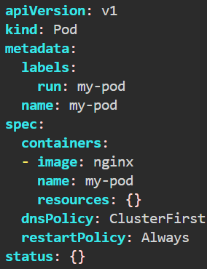 (default configs of the command)
  - kubectl create deployment my-deploy --image=nginx [ here create is used ]
    - Deployment name: my-deploy
    - ReplicaSet: my-deploy-<hash>
    - Pod: my-deploy-<hash>-<random>
    - labels: app:my-deploy
    - These are the things kubectl create commands can create. pod cannot be created using kubectl create command
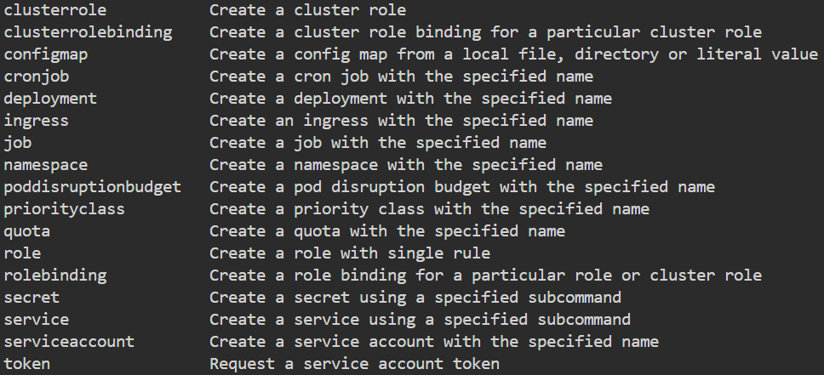
    - 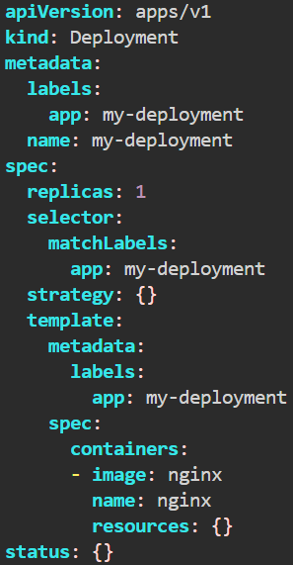 (default configs of the command)
labels are automatically added.
  - ReplicaSet cannot be created directly using imperative way, because Deployment is there to create and manage replicasets.
  - kubectl expose takes replication controller, service, deployment, or pod and creates a Service to expose that.
    - 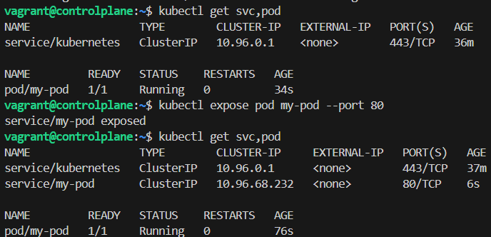
you can see here, It created a service named my-pod. Ifs of type ClusterIP which is default.
    - If you give --type=NodePort flag, then it’ll create a service of type NodePort
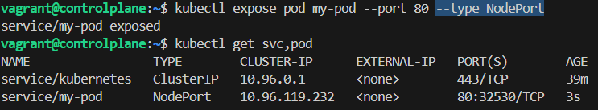
  - 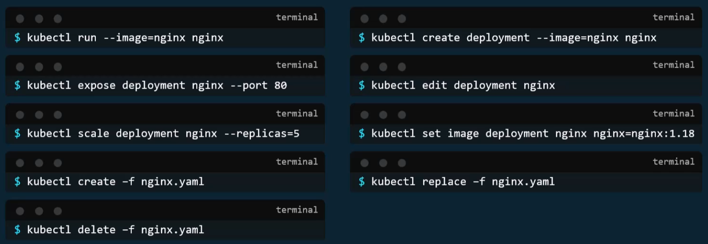
[ these are the imperative commands ]
create -f is imperative because if already the same config present it’ll fail, where as apply -f will not fail.

- Important trick
  - kubectl create deployment my-deploy --image=nginx --dry-run=client -o yaml
kubectl run my-pod --image=nginx --dry-run=client -o yaml
    - it’ll give the yaml file of default deployment, remove the unnecessary fields, customize that, and create deployment
    - Because of the flag --dry-run=client it’ll not create the deployment, just simulate and give the output as yaml.
  - kubectl get pod my-pod -o yaml
    - It’ll give the running config of the pod as an yaml.
    - Can be done with any types of objects i.e. pod, replica set, container runtime, deployment ..etc
    - But it’ll contain a lot of things, that needs to be removed.

- 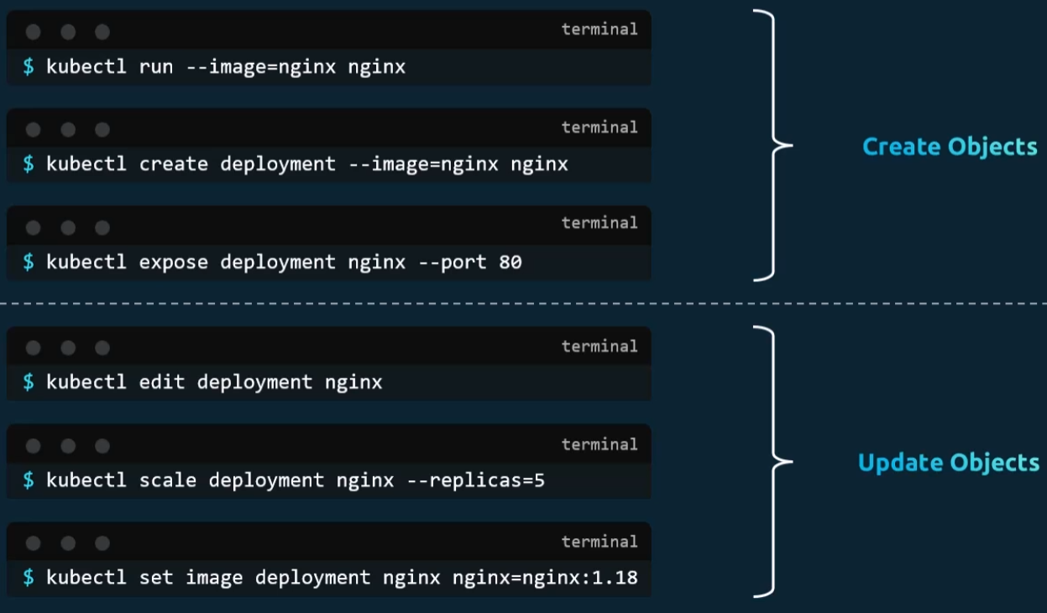
- edit vs replace command
  - kubectl edit command open the running status of the object (pod, replicaset, replication controller, deployment, service ..etc) in a yaml file.
This configurations are there in the memory, not stored in the yaml file that was being used to create the object.
So, if you do kubectl edit then it’ll ont have any track of the changes. If someone later want to update the object, and he sees the yaml file present (not the running configuration yaml) and try to update, it might do some wrong changes in the running object.
  - kubectl replace command uses the physical yaml file to update the running object.
It does dumb update in the running object. Whatever there in the physical yaml, it’ll update all the things and delete the configs which are not present in that physical yaml file.
By default it doesn’t delete the current object (if anything doesn’t match with physical yaml), to replace force fully you can give the flag --force.
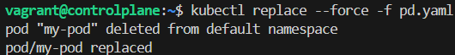
It looks similar to kubectl apply, but kubectl apply does intelligent update. It finds the diff between running object and the physical yaml (used to update the object) and update those only.
It doesn’t delete any configs which are not present in the current yaml but there in the running object.
kubectl apply is declarative command.
- If there are multiple files out of which objects will have to be created, then just give the path of the directory where those are present to kubectl apply, it’ll create all those.
kubectl apply -f <path where all files are present>

--- kubectl apply internals ---
- [ here I’ll take an example of a deployment named my-dep ]
- There are 3 things.
yaml (file that you write)
last applied config (when you execute kubectl get deploy my-dep -o yaml) [JSON format]
live config (when you execute kubectl describe deploy my-dep)
[ deploy is shorthand of deployment ]
  - Whenever you do declarative change using a yaml i.e.
kubectl apply -f my-dep.yaml
it changes both live config, last applied config. and obviously yaml is changed by you only.
  - Whenever you do imperative change using the command i.e.
kubectl scale deployment my-dep --replicas=5
it changes only live config. Last applied config will not be changed. And of cource, yaml has not been changed.
  - 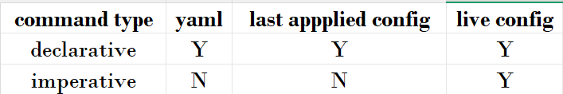
- Lets see the below example: --------------
- Stage-1; declarative; using kubectl apply -f my-dep.yaml
  - The below is my initial yaml config
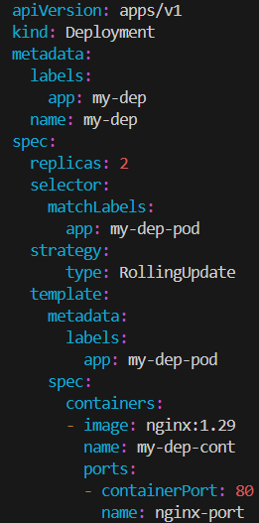 [ just look into replicas, image ]
  - replicas: 2 ; image: nginx:1.29
  - Last applied configuration [ kubectl get deploy my-dep -o yaml ] : {"apiVersion":"apps/v1","kind":"Deployment","metadata":{"annotations":{},"labels":{"app":"my-dep"},"name":"my-dep","namespace":"default"},"spec":{"replicas":2,"selector":{"matchLabels":{"app":"my-dep-pod"}},"strategy":{"type":"RollingUpdate"},"template":{"metadata":{"labels":{"app":"my-dep-pod"}},"spec":{"containers":[{"image":"nginx:1.29","name":"my-dep-cont","ports":[{"containerPort":80,"name":"nginx-port"}]}]}}}}
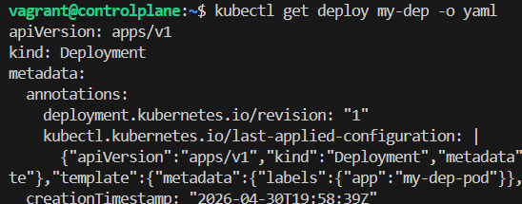
[template.spec.containers.image: nginx:1.29 ]
[ the last-applied-configuration stays inside annotation field ]
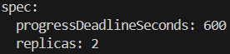 [ spec.replicas: 2]
  - Live configuration [ kubectl edit deploy my-dep (or) kubectl describe deploy my-dep ]
[ even in kubectl edit command you’ll see that json (last-applied-config), don’t change this. If you do then it’ll update the last-applied-config which is dangerous. Will discuss this ]
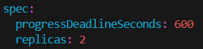 [ spec.replicas: 2]
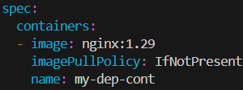 [template.spec.containers.image: nginx:1.29 ]
- Stage-2; imperative; using kubectl set image deploy my-dep my-dep-cont=nginx:1.30
[only image will be changed here keeping the replicas same]
  - yaml has not changed. So
replicas: 2 ; image: nginx:1.29 [ in yaml ]
  - last-applied-config
replicas: 2 ; image: nginx:1.29 [ in last-applied-config]
it didn’t change because the command executed was of imperative.
  - live-config
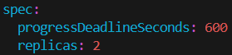 [because we have not changed]
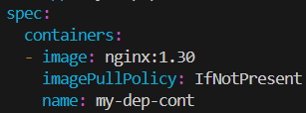[image changed to nginx:1.30]
replicas: 2 ; image: nginx:1.30 [ in live-config]
- Stage-3; declarative; using kubectl apply -f my-dep.yaml
[only replicas will be changed here]
  - 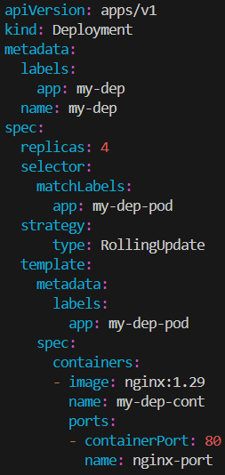 [ replicas: 4; image is showing 1.29 because we have not changed this yaml; stage-2 change was imperative]
  - yaml
replicas: 4 ; image: nginx:1.29 [ in yaml ]
  - last-applied-config
replicas: 4 ; image: nginx:1.29 [ in last-applied-config]
replicas got updated because the change was declarative.
  - live-config
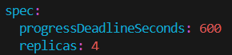
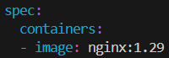
replicas: 4 ; image: nginx:1.29 [ in last-applied-config]
- F
- F
- F
- F
- kubectl diff -f simple_deployment.yaml
kubectl get -f simple_deployment.yaml -o yaml
kubectl apply view-last-updated
- F
- F
- F
- Replicas nginx
1 1.14.2 (apply)
- kubectl apply
Sets fields, that appear in the configuration file, in the live configuration.
Clears fields, that removed from the configuration file, in the live configuration.
- F
- F
- F
- F
- F
- F
- F
- F
- F
- F
- f
- F

Important Points
- Try to use imperative commands as much as you can in Exam.
- If you forget the keywords and resources, then execute kubectl api-resources you’ll get the keywords.
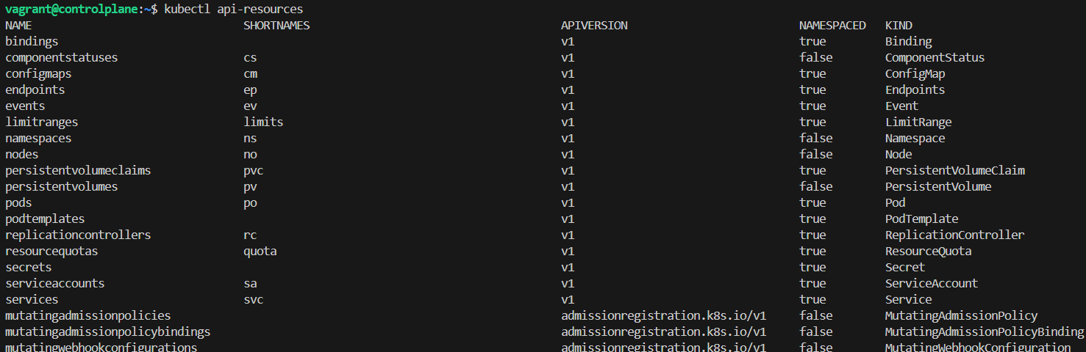
[ you can see there is a column ‘KIND’ which you can directly write in the yaml ]
  - Shortnames are also there to use in imperative commands which will SAVE TIME.
- If you want to get a documentation regarding any specific resource, you can use kubectl explain <rource name> command.
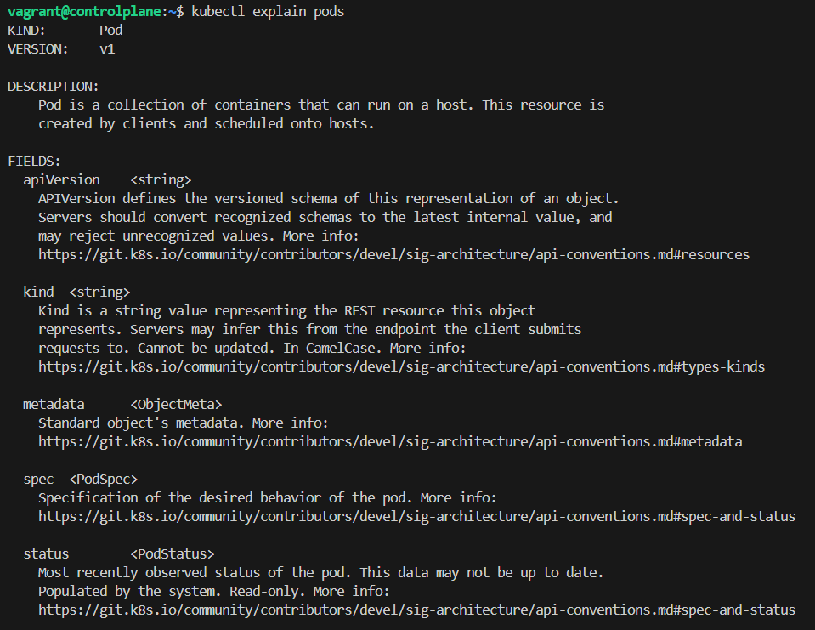
  - To go deeper into the specific fields of that resources,
kubectl explain <resource name>.<field name>
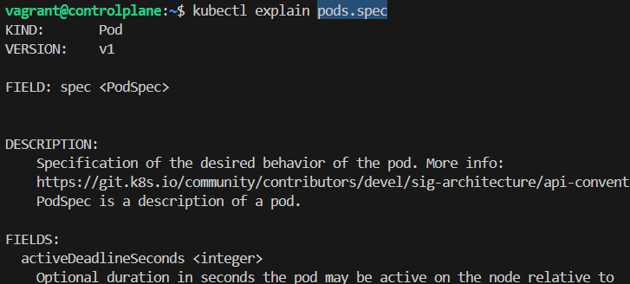If you want, more comprehensive, then use
kubectl explain <resource name> --recursive
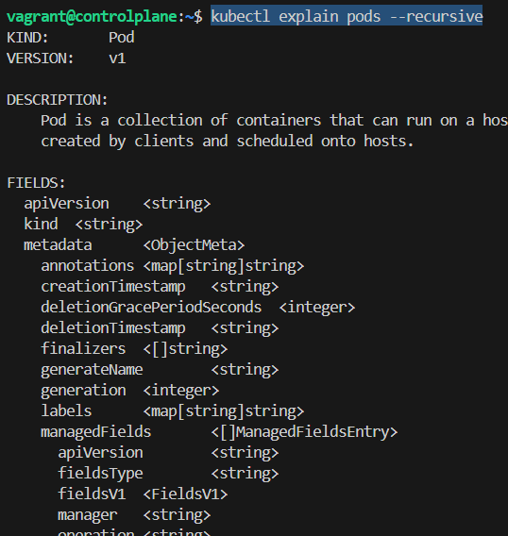
- To get a basic yaml file instead of writing from scratch, use --dry-run=client -o yaml with the command.
[ with run, create for static] [ with get if the object is already running ]
kubectl create deployment my-dep --image=nginx --dry-run=client -o yaml
kubectl run my-pod --image nginx --dry-run client -o yaml
  - 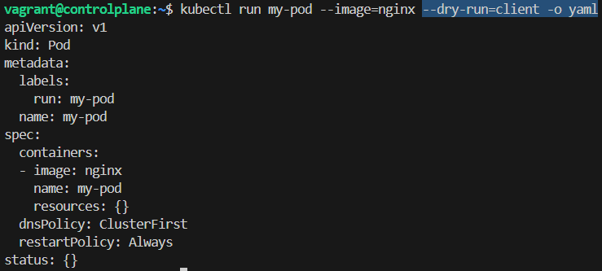
  - 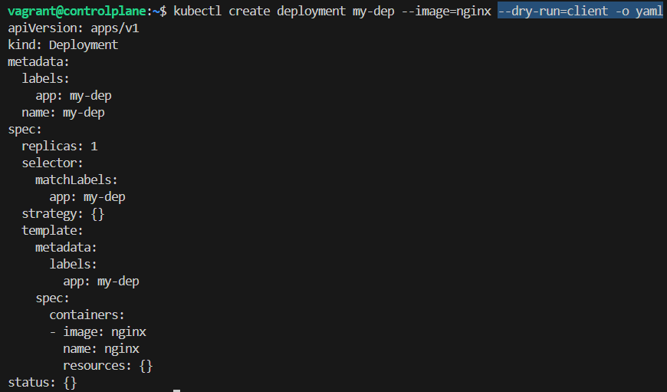

- F
- F
- F
- F
- F
- F

